**R Code for Examples in the book**

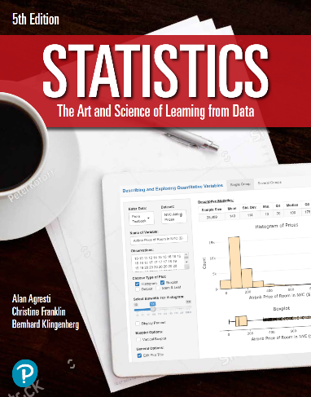

***“Statistics: The Art and Science of Learning from Data”***

**by Agresti, Franklin and Klingenberg, 5th edition**

**Chapter 5**

**Example 3: Multiple-Choice Pop Quiz – Sample Space**

## To view the sample space for all possible outcomes of this quiz

sampleSpace <- expand.grid(Q1 = c('C', 'I'),   
 Q2 = c('C', 'I'),   
 Q3 = c('C', 'I'))  
sampleSpace

## Q1 Q2 Q3  
## 1 C C C  
## 2 I C C  
## 3 C I C  
## 4 I I C  
## 5 C C I  
## 6 I C I  
## 7 C I I  
## 8 I I I